

**Digital Security for Cyber Bullying**

**Tips and Guideline**

**Number of attendees** 22 60% Females 40% Males

**Dr. Angela Al-Mamari**

Assistant professor of mental health department, Taiz University

**The Two Experts**

**Noor Khalid**

Digital Specialist

**Activity Host**

**Sukaina Mohammed** Journalist

**Activity host**

Sukaina Mohammed

Journalist and information auditor, Bachelor degree in Journalism from Faculty of Media at Sana'a University.

**The Two Experts**

**Dr. Angela Almamari**

Assistant Professor of Mental Health Department, Head of the Department of Psychology at Faculty of Arts at Taiz University, works in the field of psychological support, activist and consultant in the field of human rights, peacebuilding and gender, recently, she founded the Center for Strategic Studies to support women and children.

**Eng. Noor Khaled**

A digital specialist in YODET organization who is active in the field of digital rights and a digital security trainer, interested in cyber issues, seeking and advocating to pass a law limiting such crimes, she trained many journalists and activists in digital protection and how to protect sensitive data.

**Topics of Discussion**

1. Concept of bullying and how it manifests itself online, its forms and causes.
2. Motives of bullying, and its danger to women in particular and society in general.
3. The role of knowledge and digital security in countering and reducing bullying.
4. Examples of cases of cyberbullying and how I faced and overcame it.
5. The influence of gender in exacerbating the problem of cyberbullying.
6. The role of society and community culture in reducing cyberbullying.
7. Tips by the two experts on digital security to fight bullying and digital and psychological precautions to overcome it.

**Summary of the Session**

Speakers highlighted a wide range of challenges Yemeni women face at the level of digital security, and how this is exploited by cyber bullies and blackmailers.

These discussions focused on digital gaps that increase over time, renewal of technologies and lack of keeping pace with newer updates and applications, resulting in a state of digital insecurity, thus reflecting on the most important aspect of women, as the situation goes beyond the safety phase to directly affecting women's psychology by using poor methods of cyberbullying.

The current situation in the country, the difficulty of providing the internet makes security gaps more privileged and expose many to digital risks, women are at the forefront of digital illiteracy, which is parallel to poor internet connection. The discussion centred on the need to raise digital awareness, motivate women and provide more awareness and educational resources not only for women but for society as a whole; Because the risk to women does not come solely from women, cyberbullying is a widespread situation for which women remain more vulnerable.

The journey towards the empowerment of Yemeni women includes giving them safety at all levels, accepting them as an important figure at the social level, addressing the challenges they face and standing in the face of their evolution, such as digital imbalances that are used to marginalize them and discourage them to continue, ultimately creating a resilient and capable society.

The discussion then moved on to the two experts ' review of their materials that we attended, as Dr. Angela Al-Mamari, Assistant Professor of mental health department at Taiz University, began her presentation by talking about the causes of bullying, which centered on the theory of difference in opinion and trends, conspiracy theory, cultural and intellectual background, wrong upbringing, in addition to the lack of an effective system to confront bullying.

After that, Dr. Al-Mamari's talk focused on the places where bullying occurs, as social media comes at the top of the list, followed by places of study, work, public places and home. during her talk, she discussed a number of bullying images that occur, and how they start and escalate frequently until they reach the peak of unacceptable bullying, which negatively reflects on the affected person's psychology

There has also been extensive talk of the widespread prevalence of cyberbullying online in general, the violation of privacy and direct abuse of the victim, and its psychological and social impact, which has evolved into a sense of isolation, insecurity and loss of trust.

While the presentation of the digital specialist eng. Nour Khaled focused on the role played by digital security in the fight against cyberbullying, she talked in the same context about what digital security is, assessing the risks that women may be exposed to while dealing with devices and smartphones, and reviewed the forms of cyberbullying, and how to adapt and exploit digital devices to reach these forms.

In her speech, Eng. Noor Khalid pointed out that women are the most vulnerable group to digital attacks and cyberbullying because they are silent and do not show any reaction when they are subjected to any form of bullying, and attributed the reason for this to the social violence that may result greater than the violence they may be exposed to digitally and up to physical violence.

At the end of their talk, Dr. Angela Al-Mamari and Eng. Noor Khaled provided some important tips to the participants in the event to ensure them minimal digital security, and mitigate and limit attempts at cyberbullying.

The two experts stressed the need to involve the community in the process of monitoring bullying cases, working to promote awareness about the effects of cyberbullying and its risks, encouraging reporting of bullying, providing support for this, passing laws and legislation to protect those affected from cyberbullying, in addition to strengthening psychological and social support services for the affected indeviduals.

They also drew attention to the importance of digital awareness and learning data protection skills in a way that does not lead to a violation of your privacy and the resulting bullying and blackmail.

As they were also invited to provide models and success stories of survivors who were able to face digital challenges and the resulting bullying and blackmail to tell their inspiring experiences and enhance the safety of women in society, and give them the opportunity to reproduce the experience again.

**Detailes**

|  |  |
| --- | --- |
| **1** | **Concept of bullying and how it manifests itself online, its forms and causes.** |

**Dr. Angela Al-Mamari**

Dr. Angela Al-Mamari defined cyberbullying as “*bullying using digital technologies*”, and it can occur on social media, messaging, gaming platforms and phones, which is a repetitive behavior aimed at scaring or provoking those targeted by it or discrediting them.

that it comes in the form of:

* Spreading lies about someone or posting embarrassing photos of them on social media
* Sending malicious messages or threats via messaging
* Impersonate someone and send offensive messages to others.

Bullying often happens face - to-face, but cyberbullying leaves a digital footprint-a record that can be used and provides evidence to help stop the abuse, if the capabilities and interested government agencies are available or have the ability to control.

Bullying occurs as a result of differences in opinion and attitudes, conspiracy theory, cultural and intellectual background, wrong upbringing, in addition to the lack of an effective system to counter and reduce bullying.

|  |  |
| --- | --- |
| **2** | **Motives of bullying, and its danger to women in particular and society in general.** |

**Dr. Angela Al-Mamari**

In this context, Dr. Angela Al-Mamari's talk focused on the places where bullying occurs in general and cyberbullying in particular. social media of all kinds and online messaging applications have become the focus from which bullying spreads, followed by workplaces, studies and public places, and the home does not come out of the scope of these places because of direct bullying.

As for the danger of cyberbullying, Dr. Angela, in her review, came up with framing this into four risks with sub-extensions, the wide spread of the internet and social media causes the violation of the victim's privacy and the dissemination of abusive content on a very large scale, and the anonymity that the bully feels safe while he is behind the screen where no one knows him and he can use about the victim's feeling of isolation and lack of feeling safety and loss of trust.

These risks enhance a number of side effects for those who are subjected to cyberbullying and worsen their psychological condition, the economic impact may lead women to stop working, thus stop supporting their family and enter into complex psychological complications such as frequent psychological impact such as anxiety, stress and depression, based on this health impact may lead women to chronic diseases and possibly death, in addition to the social impact of being anti-social, introversion, poor effectiveness and community participation, and turning a person into a restricted person unable to give and take initiative as a result of being bullied, in addition to the educational and career impact which turns the victim into a pile of self-contradictions. It leads to failure for reasons that have nothing to do with it, and as a result of methods that have become a great burden, and need urgent radical solutions.

Cyberbullying undermines women's self-confidence, which means lack of access to jobs, restricting their freedom to express their views and participate in public dialogue, and ultimately, losing social stability.

|  |  |
| --- | --- |
| **3** | **The role of knowledge and digital security in countering and reducing bullying.** |

**Eng. Noor Khaled**

Noor Khaled, an engineer and digital specialist, discussed in her presentation the role of knowledge and digital security in countering and reducing bullying, as with the rapid development of information and technology, countries, institutions and individuals have become vulnerable to cyber threats and cyberbullying.   
It is known that cyberbullying is widespread, especially among young people, because of the spread of social media Facebook - WhatsApp - Twitter - Instagram-SnapChat etc. With the increasing demand of Yemenis to use it as a source of entertainment, work and exchange of views, the phenomenon of cyberbullying has emerged significantly in a way that is cause for concern. Therefore, studies are also needed to reduce the negative effects and damage caused by exposure to cyberbullying and provide moral support.

In her presentation, Noor Khalid said that the targeting of many young people and girls on the internet is due to conflicting opinions and ideas, regional or tribal differences, different origin, or those with special needs, and this is what makes cyberbullying the main reason for the increase in suicide rates.

At a time when the risk of sharing personal data and information is increasing for most internet users, this risk is doubled if the data is shared by women or young people, this risk may manifest itself in the form of job loss, damage to family relationships and friendships, and threats of physical harm.

Thus, it is important to consider digital security and the protection of sensitive data as an integral part of the behavior of males and female on the internet.

She alerted the girls to a number of forms of cyberbullying that they should pay attention to, such as harassment that come in offensive and socially and morally inappropriate messages, negative and insulting comments, defamation through fake information and dangerous rumors about another person for the purpose of mocking and defamation, or posting photos on the public digital space without the permission of the owner, in addition to identity cyberstalking, such as repeatedly sending online messages containing threats of harm, harassment or intimidating messages

|  |  |
| --- | --- |
| **4** | **Examples of cases of cyberbullying and how I faced and overcame it.** |

**Audience**

Women have spoken about being bullied in their workplaces, including Fatima BaWazier, who has faced bullying in her workplaces that reaches social media. Although this affects her health and psychology and sometimes discourages her from continuing to work, she is confronted with it, trying to overcome it by proving her presence and self, and believing in her abilities as she said in her intervention.

The same is the case for Haifa Al-audeini, but she entered into psychological complications that reached the point of depression, and trying to stop working altogether or factors that relieve her stress as a result of being bullied online, but she overcame this with the help of her colleagues who contributed to her regaining her energy again.

The public made some interventions that tell the experiences of overcoming this problem, which, according to some comments, did not exclude anyone, and therefore the family plays a big role in light of the lack and absence of government and civil means at the level of reporting, intervention and confrontation, and in light of the limited digital assistance and its availability free of charge to all.

|  |  |
| --- | --- |
| **5** | **The influence of gender in exacerbating the problem of cyberbullying.** |

**Eng. Noor Khaled**

Eng. Nour Khaled believes that gender often significantly affects the experience of users on the internet and on their behavior during presence and interaction in the digital space, and studies have proven that the most exposed category to cyberbullying is women, followed by children.

**Why women in particular?**

Because when women are exposed to violence, they remain silent for fear of raising their voices that there is violence they are exposed to because the societal violence that falls on them is greater than blackmail itself, so it is important to work on protection activities and we are making a link between society and service-providing institutions, there are many services provided to women, whether they are health, police or legal, such as pleading and legal advice for free, or psychosocial support services or shelter services in case of first-degree danger, means YODET organization, which works with them in the field of digital protection.

|  |  |
| --- | --- |
| **6** | **The role of society and community culture in reducing cyberbullying.** |

**Dr. Angela Almamari**

It is important that society plays a real role in confronting cyberbullying of all kinds, and that this role has a tangible adoption and impact that limits the worsening problem, as it can monitor and intervene early by monitoring cases of bullying in schools and society and early intervention to prevent the problem from worsening, promote awareness and education about cyberbullying and its effects on individuals and society in general, encourage reporting of bullying cases, provide the necessary support and assistance to them, encourage individuals to talk about their experiences in dealing with cyberbullying and provide the necessary support and assistance to affected people

It is also important to pass laws and legislation to protect those affected by cyber blackmail, strengthen psychological and social support services for those affected by cyberbullying, in addition to enhancing security and digital protection.

|  |  |
| --- | --- |
| **7** | **Tips by the two experts on digital security to combat bullying and digital and psychological precautions to overcome it.** |

**Dr. Angela Almamari**

* Be as close as possible to the person being bullied, make him feel that he is not alone, ask him not to pay attention to bullies, and occupy himself with other things while browsing social media to help him get out of the bullying trap.
* It is important to ignore the bullies, turn the bullying incident in your favor by showing a more solid attitude and respond to the bully in kind so that he feels embarrassed and with a strong reaction that he did not expect.
* We need to talk to our friends about what happened to us, listen to their experiences and advice about it, and we can, if available, report the incident of bullying and follow up the procedures with the concerned authorities, and we can work together through personal and community initiatives that adopt confronting bullying of all kinds, awareness and education about the importance of combating it through social media and even in the field at work, study, strolling and even at home.
* We must use a male or female digital expert in case the bully exceeds his limits and turns to the practice of extortion to obtain physical things as a result of obtaining information, data or private photos, so the expert can guide you to the necessary steps to follow to overcome the situation and overcome it

**Eng. Noor Khaled**

There are many tips that should be taken into account in terms of digital security and securing personal accounts in social media to protect private data, which is usually one of the entrances of bullies and one of their special things is that they found what helps them to reach you in some way, so I summarize the most valuble tips here:

* Sufficient awareness that bullying is a crime, and no one has the right to bully, insult or cures under any reason.
* Take advantage of the BERIFY website, which is a photo upload website, to check if there are other people who have posted your photos without your knowledge! also, Google Alarm
* The need to learn digital skills and digital awareness of data protection and privacy and take advantage of digital security training courses offered by some organizations such as YODET.
* Do not share your password with anyone and renew it every once in a while, and make sure that you activate the two-factor authentication steps, software updates and activate the firewall and antivirus software
* Avoid accessing your private accounts via a public WiFi network or from other people's devices, and always make sure to turn off the GPS in case it is not needed.
* Very careful not to open any links or download photos or documents and preferably be checked before opening them by Virusetotal.
* Think twice before posting anything online, and don't share your personal information in a way that might cause you harm or embarrassment.
* Ignore abusive messages and report them to technical authorities to close the bully's account, such as YODET, or some other initiatives.
* Avoid sharing offensive content to others.
* 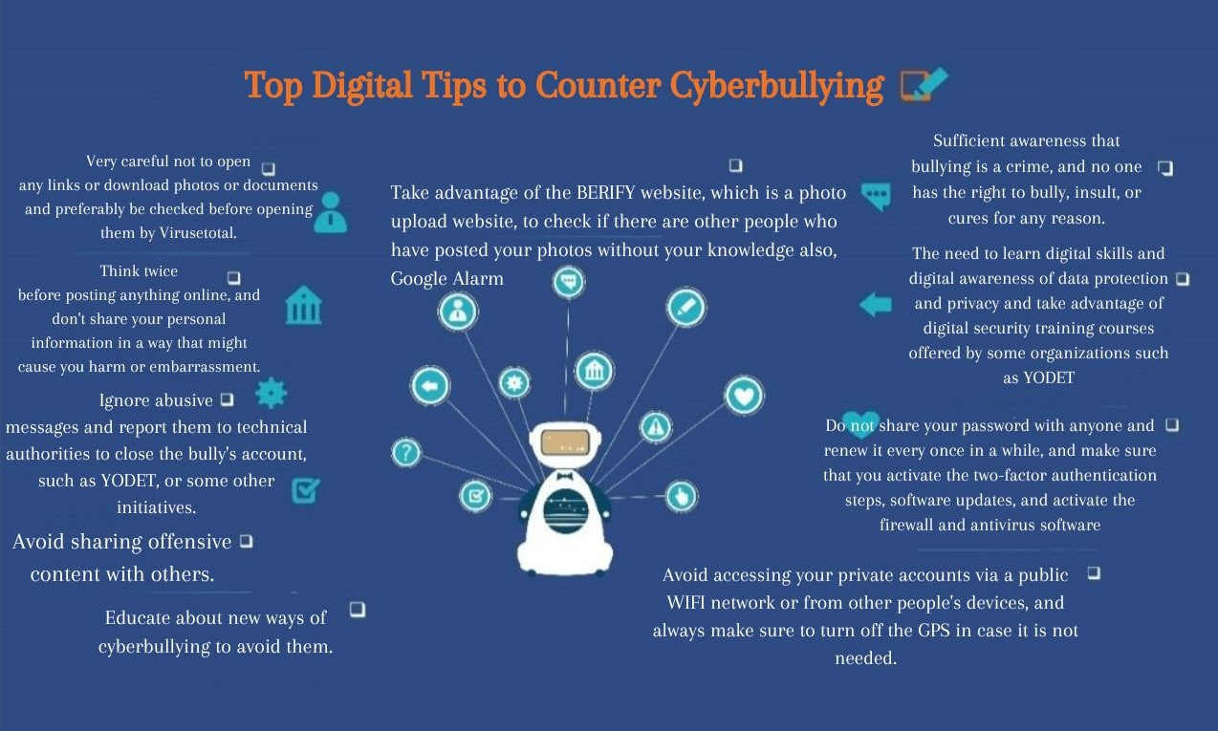Educate about new ways of cyberbullying to avoid them.