

**Breaking barriers:**

**A Dialogue on the Empowerment of Marginalized Women Working in** **the Hygiene Sector in Yemen**

November 11, 2023 - Taiz - 9 am - 12 pm

**Number of attendees** 20 people, 70% women and 30% male

**Experts**

* Misk Al-Maqrami, Chief Executive of the Kifaya Foundation and an activist in the field of marginalized rights
* Ghadeer Al-Adani, a journalist from the marginalized group
* Abdo Saeed, Chief executive of the Future Foundation, and an employee at the Hygiene and Improvement Fund

**Activity facilitator** Rania Abdullah, journalist and member of the Makanti Network for supporting women’s issues

**Activity facilitator**

**Rania Abdullah**, a journalist and member of the Makanti Network to support women’s issues in Yemen, which was formed by the French Agency for Media Development (CFI) in 2020, cooperating with a number of local platforms and websites, and former editorial secretary of Al-Usra magazine.

**Experts**

**Misk Al-Maqrami,** Chief Executive of the Kifaya Development Foundation and an activist in the field of rights and support for the marginalized group, has community contributions as a mediator in resolving conflicts, contributing to the process of community integration in Taiz.

**Abdo Saeed,** Chief Executive of the Future Foundation for Development, a civil activist in the issues of marginalized people, and an employee at the Hygiene and Improvement Fund in Taiz Governorate.

**Ghadeer Al-Adani,** a journalist from the marginalized group, has press materials published on Yemeni platforms about the marginalized group, their suffering, and their needs.

**Workshop topics**

* The situation of marginalized women working in the hygiene sector before and after the war.
* Marginalized women working in the sector of hygiene.
* Issues related to marginalized women.
* Working groups to discuss issues, propose, solutions and recommendations.

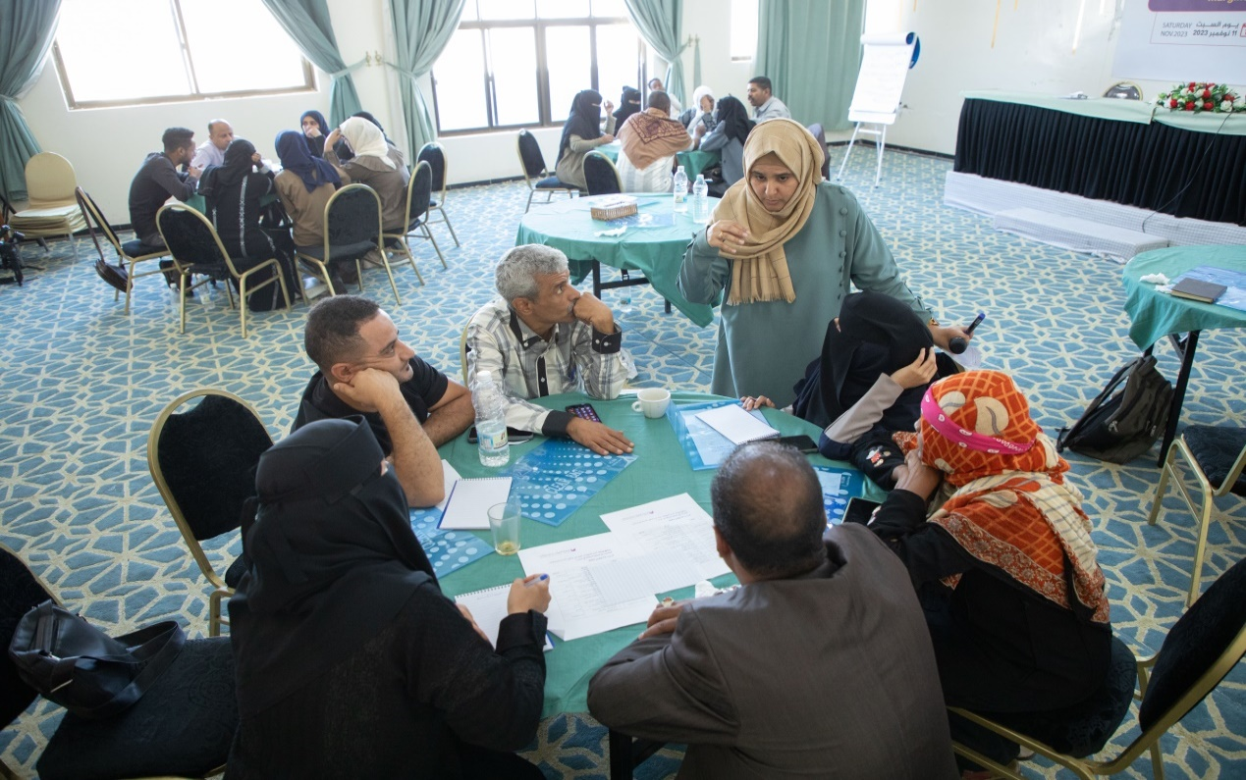

Working groups to propose solutions and recommendations to the issues of women working in the field of hygiene – Taiz

**Introduction: Workshop facilitator**

Marginalized women, in general, suffer from various violations that affect them in their daily lives, and the racism they suffer from is at the top of the list of these violations, especially women working in the sector of hygiene in Yemen, as most women working in the sector of hygiene work with forced labor and daily wages, for a small fee, not able to fulfill the basic requirements of life, as the majority of them support their families, as a result of their reliance on what they call a job, which can be considered metaphorically for them as a semi-permanent or guaranteed source of income, as no other groups work in the same sector.

A situation that opens another chapter of suffering for them, such as being deprived of their guaranteed legal rights, and not being provided with health insurance that they can benefit from when they are exposed to any dangers in the field or when they become ill, in addition to their working in the harshest conditions without any financial or preventive benefits, as they do not stop performing their duties, they don't stop doing their job under any circumstances., whether climatic or during the spread of epidemics and seasonal diseases of all kinds, as they are considered more vulnerable to infection than others. When COVID-19 spread, women working in the cleaning sector continued to work without any protection or safety and HIV prevention tools.

Given the importance of addressing what marginalized women working in the hygiene sector suffer from, Voices Platform invited Yemeni women working in the hygiene sector, male and female activists, relevant groups, representatives of government offices, and some relevant civil society organizations working to care for the marginalized group to participate in this workshop, which It is titled “***Breaking Barriers: A Dialogue on Empowering Marginalized Working Women in the hygiene Sector in Yemen*.”** The participants were carefully selected and paid attention to the diversity of their specializations to enrich the topic and come up with solutions and recommendations for several issues and problems related to marginalized women and hygiene female workers specifically.

**Workshop Summary**

The workshop began at 9 a.m. on Saturday, November 11, at the beginning of the workshop, attendees were welcomed, the speakers were introduced, and the topic of the workshop was presented, which revolved around empowering marginalized women working in the sector of hygiene through a dialogue workshop aimed at breaking down the barriers that stand in the way of the marginalized women, and introducing the " Yemeni women's voices Platform ".

The speakers shed light on the problems and issues of marginalized women, and highlighted the challenges faced by marginalized women working in the sector of hygiene, the discrimination they are exposed to, and the deprivation of legal and administrative rights, the interventions lasted for 40 minutes.

The workshop was started by Misk Al-Maqrami, Head of Kifaya Development Foundation and an activist in the field of marginalized rights, who spoke about the situation of marginalized women before and after the war, specifically women working in the sector of hygiene, pointing out that marginalized women face complex violations at the level of rights and freedoms, and this is what makes them more vulnerable, and this is supported by what she considered societal intransigence based on customs and traditions that treat marginalized women with inferiority and discrimination, which is reflected on the hygiene female workers, who are confined to this work as negative discrimination against them and their energies, and consider it systematic exploitation, as there are no rights given and no compensation to reward the effort expended.

**Misk Al-Maqrami: “*Marginalized women face complex violations at the level of rights and freedoms, and this makes them more vulnerable.”***

Misk Al-Maqrami proposed several recommendations that could contribute to the solution, such as promoting a culture of integration and social coexistence among all groups, fair application of the labor law, officially approving contracts for female hygiene workers, and increasing what a worker in the hygiene sector receives because she does hard work, in addition to working on various programs by government bodies ,local and international organizations to develop marginalized women and eliminate illiteracy among marginalized women.

For his part, Abdo Saeed the Head of Future Foundation for Development, and an employee at the Hygiene and Improvement Fund, focused on the problems of women working in the sector of hygiene and improvement, in his narration, he mentioned several problems that he attributed to the legal and administrative side, represented by the Fund and the local authority, as women working in the sector of hygiene face discrimination in the entitlements they receive which considered unofficial, as well as the lack of safety and protection tools during work, in addition to the lack of commitment to applying the labor law, similar to other institutions, where women are not granted maternity and infant leave, nor even sick leave, in addition to the lack of qualification and training at all levels, and the lack of health insurance for workers in the hygiene sector.

**Abdo Saeed: “*Women working in the*** ***hygiene sector face discrimination in their benefits, as well as the lack of safety and protection tools while working, in addition to the lack of commitment to apply the labor law, similar to other institutions, where women are not granted maternity and infant leave, or even sick leave*.”**

In his intervention, he proposed activating the Yemeni law for the rights of Yemeni working women and introducing women’s rights in Yemeni labor legislation and law from a gender perspective, and obliging government institutions related to female workers in the sector of hygiene and improvement, such as the Hygiene and Improvement Fund, to work on empowering programs for women working in this sector, and improvement in a way that contributes to improve their income and enhancing their social status, in addition to coordinating with civil society institutions and international organizations to direct specialized programs in rehabilitating and training marginalized women, specifically those working in the sector of hygiene, and improving other skills and professions that can help them provide an income that guarantees the minimum necessary family needs.

As for Ghadeer Al-Adani, a journalist interested in the affairs of the marginalized, her intervention was about the issues of marginalized women in general, as she brought back what happens to marginalized women to the social and cultural history of Yemen, which is burdened with a great legacy of obstacles, difficulties, views, cultures, and even social customs and traditions that were and still until the day, confining the marginalized group from the life of Yemeni society, which makes successive generations of this black-skinned group live amidst a chronic state of social and cultural alienation within their homeland, and this is the origin and beginning of all issues, as she pointed out.

**Ghadeer Al-Adani: “*What happens to marginalized women goes back to the social and cultural history of Yemen, which is burdened with a great legacy of obstacles, difficulties, views, cultures, and even social customs and traditions that were and still until the day, restricting the marginalized group from the life of Yemeni society*.”**

Ghader Al-Adani believes that there is a life completely different from the rest of the societal groups that the marginalized group lives, and therefore this is reflected in the women who pay the bill, such as the lack of multiple jobs, the lack of adequate housing, and the presence of social disparities at the level of dealing and action. These are practices on a discriminatory basis and have an impact on widening the gap between this group and the rest of the groups.

It proposes working to enhance the culture of social and cultural integration between the marginalized and other segments of society, activating international laws and resolutions, including the Law on Convention on the Elimination of All Forms of Discrimination against Women (CEDAW), and developing specific programs to empower marginalized women in several government institutions not limited to the sector of hygiene and improvement, as well involving marginalized women in other fields of work, including peacemaking and confronting violence of all kinds, by allocating a percentage or seats by institutions that implement relevant projects, in addition to educating marginalized women working in the sector of hygiene and improvement of their legally guaranteed rights during their work and in the compensation they deserve.

After the experts’ interventions, the floor was opened for discussion, and comments were presented by the participants. Their contributions varied, which further enriched the discussion, in which there was a consensus that this was a qualitative workshop and first of its kind, devoted to discussing the problems of women working in the sector of hygiene. Also, the marginalized women felt comfortable that they had presented the workshop and participated in it.

**There was a consensus that this was a qualitative workshop, the first of its kind, dedicated to discussing the problems of women working in the sector of hygiene, and marginalized women felt comfortable that they presented the workshop and participated in it.**

Hazza Qaed spoke about the lack of official contracts for female hygiene workers, noting that they receive their salaries as aid and support not as wages, and this is what puts them on the verge of danger, while lawyer Raghda Al-Maqtari focused on the necessity of a legal culture for women working in the field of hygiene so they are aware of what they have and what they are owed, and in a way that ensures the application of the labor law.

The Head of the National Committee for Women in Taiz, Sabah Al-Sharabi, stressed and held the Hygiene and Improvement Fund responsible for this, in addition to institutions and activists interested in supporting the rights of the marginalized group.

In the second part of the workshop, the participants were divided into three working groups, each group headed by an expert from male and female speakers, the problems of marginalized women working in the hygiene sector were identified, and recommendations and solutions were come up with the solutions and recommendations were discussed between the groups and experts, then each A group reviews its work and discusses it with the rest of the groups.

The workshop came up with a set of recommendations that were agreed upon by the working groups on the importance of legal awareness, combating illiteracy, and increasing administrative awareness of female hygiene workers as foundations upon which there can be tangible empowerment of women working in the hygiene sector, suggesting the existence of specialized programs by relevant government institutions ,local and international organizations as well as the need to direct interventions to ensure improvement of their legal and financial situation in the short and long term.

Reem Saeed, one of the hygiene workers who attended the workshop, expressed her happiness at attending and participating in the discussion which she saw as her own, it was the first time that Reem participated regarding her case, which was a source of happiness and admiration for her.

Reem spoke while discussing the outcomes of the work group in which she participated, and she talked about her experience, what she suffers in her work, and how society is dealing with her, amid warm applause and wide praise for her courage by those present, both male and female.

**Details**

* **Summary of interventions**
* **The situation of marginalized women working in the sector of hygiene before and after the war**

**Misk Al-Makarmi - Head of the Kifaya Development Foundation and an activist in the field of rights and support for marginalized people**

At the beginning of her intervention, Misk Al-Makarmi touched on the suffering of marginalized women, who suffer from compound marginalization, an inferiority view towards them, and exclusion from participation, whether on the political and social level or even while carrying out their work in their job, as customs and traditions played a major role in perpetuating the view of inferiority and racism against marginalized women. Folk proverbs even mention and perpetuate the bad customs that work to oppress marginalized women such that they do not have their rights as black women, and all of this deprives them of participating effectively in the social, economic, and political aspects. Therefore, marginalized women suffer from the terrible trinity: a high illiteracy rate of 95%, Poverty rate of 94%, and 95% suffer from various rights violations.

Marginalized women suffer from violations because they are women first and black women second, as they are excluded from participation in general mainly for these two reasons.

Marginalized women before the war were and still are suffering from poverty, illiteracy, and violations, and the war increased those violations to which marginalized women were exposed due to the woman’s displacement to different places, where she is violated because she is a black woman.

When comparing the reality of marginalized women before the war, they were working in the lowest jobs, either in the hygiene sector or home service, and with the war, the circle of poverty expanded among marginalized women, and their need for work increased, so they work long hours without any application of the labor law, or what could consider it a guarantor of her rights.

Moreover, the violations inflicted on marginalized women increased during the war, without the relevant government bodies, local civil society organizations, or international organizations working in the field of women’s empowerment doing justice to them. However, there were some timid attempts when marginalized women were exposed to violations, the responsible authorities did not equate them with other women or grant her rights or be treated fairly according to the law. We have had many incidents documenting violations against marginalized women that led to their injustice and persecution, including the crime of raping two marginalized girls. We referred the case to the judiciary, but unfortunately, the judge ruled to imprison the perpetrator for only six months. This is another violation done by those who are supposed to work to protect citizens, but because the victims are marginalized, they have been underestimated and treated with inferiority.

In addition to the work of marginalized women, the sector of hygiene has been designated as the only work available to marginalized women to work in. This is one of the violations that marginalized women have suffered because they have been confined to it, as they work in the streets to clean, without the slightest protection or provide sterile materials that protect them from diseases during their work, or protective materials that protect them from exposure to any physical risks while collecting and carrying waste, which is what the competent authorities in the Hygiene and Improvement Fund must provide in terms of tools and means to protect female workers from transmission of infection or exposure to any other risks.

Many women are exposed to direct physical and disease risks, which causes them to transmit diseases and infections to their homes and children, and here increases the extent of suffering and tragedy affecting marginalized women.

Marginalized women also do not receive free medical care or health insurance according to the labor law, as many diseases have spread between marginalized women working in the field of cleaning and their children, such as liver disease and schistosomiasis. When the coronavirus pandemic spread, many marginalized women were infected and transmitted the infection to their children due to the waste they were dealing with without safety tools. They clean the waste that comes out of hospitals, factories, markets, and private and public facilities. However, they have not received part of their rights to treatment, immunization, or even awareness and education.

In addition, women working in the cleaning sector do not get their right to official vacations and sick leave, they work during pregnancy and work ten days after giving birth, and this is a major physical violation for them. They also do not receive a monthly salary like in other sectors but rather receive a daily wage. In exchange for her work, it does not exceed 2000 three thousand riyals. Moreover, we did not see any female field supervisors in the field of cleaning, and all field supervisors are only men, which is a violation that is added to the violation inherent in their work in cleaning streets and residential neighborhoods.

Marginalized women working in the hygiene sector during the war period suffered from risks because most of their work was in the street, they were exposed to missiles and war remnants without knowing that they were projectiles and war remnants. Marginalized women also bore great burdens in the war in terms of support and often played the role of fathers. As a result of the cessation of daily work due to military confrontations, during this period they were absent from awareness programs by organizations and local initiatives, even at the level of their presence in any activities or fields that are defined only by inferior definitions such as a cleaner, a black woman, or a woman of the middle class, not known by her name.

There must be active participation of marginalized women, in various fields and engaging in other work, so that they can reach and participate effectively, at least in the fields that constitute the majority of them, such as hygiene. Our ambition is higher to reach the point of participating in peacemaking and having a presence in comprehensive negotiations.

* **Problems of marginalized women working in the sector of hygiene and improvement**

**Abdo Saeed** - head of the Future Foundation for Development, civil activist in marginalized issues

Abdo Saeed linked his intervention to the population density in Taiz, as it is the highest among all governorates, and the availability of jobs for women in general and marginalized women in particular, he touched on the most significant problems facing women working in the sector of hygiene, and the intervention was as follows:

Despite the population density of women in Taiz Governorate, which is considered one of the largest governorates in terms of population density, women’s participation in public jobs and leadership positions is not proportional to their size in terms of population density, nor in terms of their pivotal role in all fields, and their participation in political life, or official jobs are still few, as in the last elections for local council membership at the governorate level, no woman reached local council membership.

As for its presence in public jobs at the governorate and directorate level, it is also still small, and this applies to the rest of the Yemeni governorates.

As for the marginalized woman, her exclusion and deprivation are doubled, in addition to being a woman, she is marginalized.

In conclusion, the woman working in the sector of hygiene suffers from many problems that can be listed:

* Arbitrariness and discrimination.
* Weak realistic application of women’s rights in Yemeni labor legislation and law and coming up with legislative solutions that are fair to women and focusing on studying women’s rights in Yemeni labor legislation and how to regulate these rights.
* Racism and compound discrimination against marginalized women from employers in the public and private sectors.
* Violation of the rights of marginalized women by departments affiliated with the hygiene sector.
* The woman working in the Hygiene and Improvement Fund is deprived of all the rights guaranteed to her derived from Islamic law and the legal right, such as her right to vacations (reducing working hours during pregnancy, childbirth, and breastfeeding), however, the working hours remain the same without taking into account her health status.
* Exclusion of black women from legal protection in the Office of Social Affairs and Labor, especially daily wage workers.
* Women working in the hygiene sector do not have health insurance, even though they are more vulnerable to deadly diseases.
* Failure to provide occupational safety tools.

**Abdo Saeed touched on the status of marginalized women in Yemeni law:**

The Constitution of 1971 stipulated the right to work for all citizens based on equality between them, with no difference between men and women, or any group, rather, the constitution obligated the state to take measures that would help women engage in various fields of work and reconcile their duties towards the family and its work in society, which is supposed to be obtained, especially for marginalized women who are subjected to complex racial discrimination.

Working women face legal and administrative difficulties and problems, these difficulties may occur before applying for work or during work, even though women receive the attention of international and national legal legislators, especially those who join work in extremist societies, and this requires us to activate the role of legal protection for them.

This problem appears through the discrimination between women and men in recruitment, employment and promotion, or in the failure to make provisions and create an appropriate environment for them during work due to their special circumstances, and the fact that they go through special circumstances such as pregnancy, breastfeeding, etc., and this causes them a lot of suffering, despite government directions to support women’s participation. In construction and development and achieving the principle of equal opportunities by activating legal protection for working women in Yemeni legislation related to work and public and private employment in Yemen, which contributes to the empowerment of women and their participation in work. However, the situation of marginalized women did not improve at all, and they were excluded from job privileges, and guaranteed leave for childbearing, breastfeeding, and even illness. Even worse than that, we documented cases of women working in the sector of hygiene in Taiz who worked until the last days of their pregnancy. There is a case that went into labor while doing her work in one of the streets.

* **Problems and issues related to marginalized women**

Ghadeer Al-Adani - a journalist from the marginalized group

The number of marginalized women in Yemen reaches 1,200,000 out of the total number of marginalized women in Yemen, which amounts to 3,500,000 people nationwide, according to United Nations statistics. The vast majority of them live in huts built of tin on land most of which is not theirs, and on flood drains, or in the outskirts of villages, or in isolated areas within cities where others do not mix with them.

The marginalized woman suffers from double discrimination: the first is because she is a woman, and the second is because she belongs genealogically to the group of black citizens who have come to be metaphorically called the marginalized. Not to mention that she bears the burdens of family life if she marries a marginalized man, and this is not the case with the Yemeni woman whose husband, father, or brothers support her until she gets married and the vast majority bear responsibility for themselves and their families.

**The most important issues that stand in the way of marginalized women’s lives:**

• The social and cultural history of Yemen is burdened with a great legacy of obstacles, difficulties, views, cultures, and even social customs and traditions that were and still are to this day alienating the group of marginalized people from the life of Yemeni society, which makes successive generations of this black-skinned group live amid a chronic state of social alienation. and culturally within their homeland. Accordingly, we summarize some of the factors that continue to this day to drag this inhuman legacy onto the lives of marginalized people in general and marginalized women in particular:

* The illiteracy rate among marginalized women reaches approximately 94%, and only 6% of them have the opportunity to receive education, reaching the basic and secondary levels, and 1% were able to continue university education.
* The inferior view and discrimination against them by society has created many immoral social problems, including: “sexual harassment, verbal violence, rape, and physical violence.”
* Housing that is not suitable for human living, in which most marginalized women live in tin huts that lack all health and public services, which makes them unable to appear decent or keep up with the rapid development on the ground.
* Loss of civil and economic rights by successive governments as well as by active women’s components in Yemen.
* The absence of legal and social protection for marginalized women, as all laws and social norms are absent in cases involving marginalized women.
* The social isolation imposed on them for a long time and all women dealing with these trends, which created isolation and lack of integration among women in general.
* Early marriage among marginalized women due to low awareness among parents and poor living conditions.
* Poverty or lack of craft skills and small and micro enterprises, which led to a rise in the phenomenon of begging among marginalized women in markets, streets, and rural areas.
* Lack of opportunities for marginalized women in various fields, except for work in the field of cleaning for daily wages (the forced labor system), except a very small percentage.

Marginalized women are also subjected to repeated attacks, reaching the point of beating, although this is a peculiar behavior to customs, and traditions in Yemen, as anyone who assaults a woman is considered a disgrace. Surprisingly, after the outbreak of war in 2015, there was a striking increase in the rate of social violence against vulnerable women, including marginalized women, without giving any consideration to the human and moral aspect, or even tribal custom, as what is practiced against vulnerable women is systematic discrimination and a blatant violation of human rights.

**Speakers' main recommendations**

At the end of the intervention of each of the three speakers, each of them concluded with brief recommendations confirming what they addressed during their interventions, and in accordance with the context of the proposal presented by each of them.

**Misk Al-Makrami**

• Promoting a culture of integration and social coexistence among all groups.

• Implementing the labor law, specifying the contracts of workers in the hygiene sector, and increasing what a worker in the hygiene sector receives because she does hard work.

• Various programs are implemented by government agencies, local and international organizations to develop marginalized women and eliminate illiteracy among marginalized women.

**Abdo Saeed**

* Activating the Yemeni law for the rights of Yemeni working women and introducing women’s rights in Yemeni labor legislation and law from a gender perspective.
* Identifying the obstacles to the realistic application of women’s rights in Yemeni labor legislation and coming up with legislative solutions that are fair to women (especially marginalized women against whom complex racial discrimination is practiced).
* Focus on studying women's rights in Yemeni labor legislation and law and how these rights are regulated and exercised by women and comparing this with similar legislation in some countries.
* Obligating government institutions related to women workers in the sector of hygiene and improvement, such as the Hygiene and Improvement Fund, to work on empowering programs for women working in the field of cleaning and improvement in a way that contributes to improving their income and enhancing their social status.
* Coordinating with civil society institutions and international organizations to direct specialized programs in rehabilitating and training marginalized women, specifically those working in the field of hygiene, and improving other skills and professions that can help them provide an income that guarantees the minimum necessary family needs.

**Ghadeer Al Adani**

* Working to enhance the culture of social and cultural integration between the marginalized and other groups of society.
* Activating international laws and resolutions, including the Convention on the Elimination of All Forms of Discrimination against Women (CEDAW).
* Promoting a culture of integration and coexistence with marginalized people, especially women.
* Allocating the Quota system for women in government institutions and facilities.
* Develop specific programs to empower marginalized women in several government institutions and not limit them to the field of hygiene and improvement.
* Involving marginalized women in other fields of work, including peacemaking and confronting violence of all kinds, through allocating a percentage or seats by institutions that implement related projects.
* Raising awareness of marginalized women working in the sector of hygiene and improving their legally guaranteed rights during their work and the compensation they deserve.

**Attendance interventions**

At the opening of the discussion and the interventions by the audience, the Deputy Director of the Hygiene and Improvement Fund spoke about a number of points related to the topic:

- Previous governments, represented by the Prime Minister’s Office, contributed after 2011 by putting pressure on some governors of the provinces to employ some workers officially, however, this was only done on the first section of wages. Today, many of them are on the fourth section, which is the section on aid and support, meaning if aid and support have been cut off, the salaries of hygiene workers have been cut, which do not exceed 60,000 thousand Yemeni riyals. After taxes, the workers receive 55,000 thousand Yemeni riyals. There are indeed deficiencies in the hygiene fund, but those who contributed to this deficiency are those in power.

In general, workers and administrators in the Hygiene and Improvement Fund lack health insurance and do not provide safety tools because they are at exorbitant amounts.

- In public employment, marginalized women are only allowed to work in the hygiene sector, unfortunately, as the number of marginalized women working in the hygiene sector in the city of Taiz has reached about 90 workers, and the wage law is unfair to the workers in the hygiene fund and the female workers, and a woman’s leave does not exceed more than 15 days, after giving birth, and if her leave period is prolonged, the supervisors in the field will dismiss her and replace her with another woman.

**While the intervention of lawyer Raghda Al-Maqtari - a human rights activist, was that:**

The labor law is crystal clear, and the rights and duties of women at work in general are mentioned in the law. Therefore, asking for a particular law for only marginalized women would be considered discrimination. Rather, they must take their rights as ordinary women, and not with the word “marginalized” because the marginalization of women is complete, and the Quota is in order not to marginalize all women, and it is necessary to return to the work regulations in the Fund, like any department or sector, and male and female employees in the Hygiene and Improvement Fund are supposed to focus on the regulations, as the existence of the regulations is to guarantee rights.

As for hygiene workers, they are the most marginalized due to illiteracy, and not giving the hygiene worker her legal leave in the event of childbirth, which is a month before the delivery and a month after the delivery, and reducing working hours, this is considered a violation and transgression of the law, and whoever is exposed to this violation and injustice must file a lawsuit before the arbitration committees, but unfortunately, up to this moment, no invitation has been submitted by any cleaning lady.

**As for Sabah Al-Sharabi, Head of the National Committee for Women, she said:**

We must ask the eliteworking with the marginalized who are with us today: Have you met with the 90 working women and made them aware of their rights?

In order for women who work in hygiene to be able to demand their rights, they must first know those rights, and the needs must be identified and presented to the relevant authorities, and a follow-up committee must be formed.

As for **Abdul-Ghani Aklan, a journalist and activist in the field of marginalized rights, he said:**

The problems of marginalized women are many, especially women working in the hygiene sector. Unfortunately, 90 women in the field work are without the slightest care or rights. We have witnessed more than one woman who went into labor while working in the street, without being given her legal right to leave, and they all work with the forced labor system “daily wage.” This has not been addressed before or discussed by any party, and we hope that serious solutions will be found by the concerned governmental authorities.

The closing remarks were from **Ali Al-Qabati - Deputy Director General of the Hygiene Fund for Improvement Affairs:**

In order to empower marginalized women, literacy must first be eradicated. There is also no education or qualification for this group to be decision-makers. The woman working in the field suffers most from marginalization from her supervisors in the field and their persecution. Therefore, educated female supervisors must be appointed so that they can confront these supervisors in the field. Regarding health insurance, the workers and workers at the Fund do not have health insurance, but if anyone suffers a work injury, we try not to leave him or her treated.

* **Working groups**

In the second part of the dialogue workshop, the participants were divided into three working groups, and the three experts were distributed among the groups and the discussion was moderated by the experts. Each of the working groups identified a problem for marginalized women in the field of hygiene and improvement, and that working to solve it is a key to empowering and enhancing the presence of marginalized women working in the sector of hygiene, which contributes to improving their income, introducing them to their rights that guarantee their safety, and demanding them when they need them.

|  |  |
| --- | --- |
| **Group 1** | |
| **problem** | Illiteracy among women working in the hygiene and improvement sector. |
| **Reasons** | * Bullying and discrimination in schools. * Violence in school against marginalized students. * Economic aspect "poverty". * Child labor. * Illiteracy of parents. * Lack of awareness of the importance of education and lack of ideal role models. * Feeling inferior. |
| **Solutions** | * Adopting programs to advocate for issues of violence and bullying against marginalized people. * Raising human rights awareness among the marginalized (by civil society organizations). * Working on integration programs for male and female students from marginalized groups in government schools to eliminate illiteracy in this group since childhood. * Establishing a mechanism by the local authority, represented by the Office of Education, to confront any discriminatory practices or bullying towards marginalized women or marginalized people in general during education. * Raising awareness among parents regarding children’s education. * Advocating and activating the Children's Law. * Targeting female workers in the Hygiene office in literacy programs. |

|  |  |
| --- | --- |
| **Group 2** | |
| **problem** | Weak awareness of rights among women workers in the hygiene and improvement sector. |
| **Reasons** | * Widespread illiteracy. * Poverty. * Weak awareness programs for this group of people. * Officials exploit the rights of this group due to their lack of awareness. * The practice of marginalization within the same group. * Society's discriminatory outlook based on skin color. |
| **Solutions** | * Intensify such workshops to “break the barriers” imposed on this group and introduce their rights. * Increase the spotlight on the problems suffered by this group (marginalized women). * Raising awareness of the law for this group and presenting the regulations within the Hygiene and Improvement Fund through training workshops. * Submitting these recommendations to the relevant authorities to adopt special programs for this group (marginalized women). * Diversity of participants during training workshops and inclusion of marginalized women to spread benefits and convey information to the largest possible number. * Encouraging enrollment in education, providing the necessary supplies, and providing cash and in-kind assistance. * Creating economic empowerment programs for marginalized families in a sustainable manner (tenure, retirement, and job security). * Adopting and intensifying legal awareness programs through radio awareness programs in marginalized communities and adopting the issues of the marginalized through local institutions and international organizations. * Promoting integration and coexistence programs. * Activating the role of community accountability. * Conducting awareness programs to present the problem of marginalization by the marginalized themselves and presenting programs entitled (Know Your Right). |

|  |  |
| --- | --- |
| **Group 3** | |
| **problem** | Low level of administrative and professional awareness among the hygiene ladies. |
| **Reasons** | * The high rate of illiteracy and ignorance among hygiene workers. * Absence of awareness and educational programs. * Failure to activate the rehabilitation and training department. * Absence of the Environmental Awareness Center related to hygiene and improvement and failure to activate its role. |
| **Solutions** | * Establishing centers in marginalized groups with female workers in cooperation with international organizations, the Hygiene and Improvement Fund, and the Education Office. * Creating awareness and educational programs for marginalized workers in various fields (health and administrative). * Activating the internal regulations of the Hygiene and Improvement Fund. * Finding support from international organizations to empower and qualify female hygiene workers to eradicate illiteracy in partnership with education offices. * Networking with organizations to obtain support for implementing awareness and educational programs in specific areas. * Approval of a budget for the Environmental Awareness Center by the local authority. * The local authority implements the internal regulations of the Hygiene Fund, represented by the Chairman of the Fund’s Board of Directors (Governor of Taiz). * Raising awareness of women working in the hygiene sector about all financial and administrative rights. * Raising the needs of the relevant authorities in the local authorities and establishing a follow-up and monitoring committee to implement those needs. |

**Reem breaks the barriers**

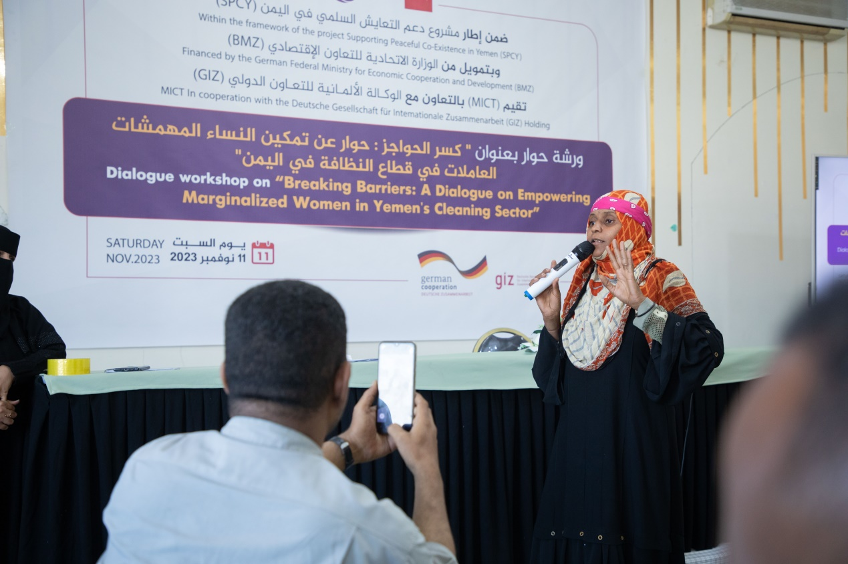

Reem Saeed Ahmed and her colleague Yasmine Hazza, who are hygiene workers, did not participate in any workshops related to marginalized women, and they had not previously been invited to attend any workshop or seminars of any kind, and this was their first attendance.

This workshop was a valuable opportunity for Reem to express her suffering during her field work in hygiene. Reem spoke in front of experts and officials in the Hygiene and Improvement Fund, participants including jurists and activists, and representatives of civil society organizations. The attendees listened to her speech and interacted with her, as she explained the suffering that she is suffering from and her colleagues working in the hygiene sector.

Reem, who participated in one of the work groups and was present at the workshop since its inception, said: “We, as women hygiene workers, work from early morning until noon cleaning the streets with simple capabilities, and we do not have any tools for protection and disease prevention, and the most annoying thing for us as female workers is being treated with inferiority and contempt by shop owners or those passing by in the streets. They believe that we are obliged to clean up their dirt, and they do not commit to throwing away waste and rubbish in their places. Rather, they throw them into the street, and we pick them up and clean the street.”

Reem added while reviewing the problems with the group with which she participated in developing solutions and recommendations: “Illiteracy is widespread among us marginalized people, especially women, for several reasons, the most important of which is poverty, discrimination against us as a marginalized group, and bullying in schools, whether by school administrations or students, and our children are also deprived from education for the same reasons.”

Reem concluded her speech by thanking the Yemeni Women’s Voices platform and those in charge of the workshop, hoping to see all the recommendations and solutions that were discussed in the workshop in the form of projects and programs that are implemented on the ground, and that she and the rest of her colleagues working in the field of hygiene benefit from them.